**BASIC TROUBLESHOOTING**

**HEADSET checklist – must be completely followed**

1. *Inspect the item if there is physically damage such as loosen/ exposed wire, bent or broken parts of Headset.*

**Maari po pakitignan kong meron kayo nakikitang putol o nabalatan na wire, nabali o nabasag na parte ng headset.**

#### *Have you seen the warranty sticker attached to the item? That is our proof that we tested the item first before we ship to you.*

#### Meron po ba kayo nakikitang warranty sticker na nakadikit sa item? Yan po ang patunay na tested naming ang item bago ipadala sa inyo.

#### *Check the headphone jack (microphone-pink and sound-green) if properly plugin. Check the volume button if set to high.*

#### Mangyari po suriin ang headphone jack (microphone-pink at sound-green) kong ito’y nakalapat ng mabuti sa jack ng iyong pc or laptop. Suriing mabuti ang volume button kong naka setup sa high volume.

1. ***(Isolation)****Try our headset to another working pc or laptop (not on the first device being used). Please restart after plugin then retest.*

**(Pagbubukod) Subukan itest ang aming headset sa ibang pc or laptop na gumagana (wag sa unang ginamit na pc or laptop). Paki restart pagkatapus iplugin, then retest po.**

1. *Go to* [*https://online-voice-recorder.com/*](https://online-voice-recorder.com/) *to record sound and voice recording.*

**Magpunta sa** [**https://online-voice-recorder.com/**](https://online-voice-recorder.com/) **para ma record ang tunog at boses.**

1. **Troubleshooting for Headset with noise cancellation feature (HN-620)**

#### *Check the USB if it’s properly plugged in. Check the volume button if set to high. Press the S button once or twice as well while the volume is set at max.*

#### Mangyari po suriin ang USB kung ito’y nakasaksak ng mabuti sa port ng iyong pc or laptop. Suriin mabuti ang volume button kong naka setup sa high volume. Pindutin ng isa o dalawang beses ang S button ng naka high volume.

#### Static Sound (unrecognized sound)

#### Try to use other usb port, preferably confirm as 100% working

#### Gumamit ng ibang USB port, na kompirmadong 100% gumagana

1. *If all above testing failed, request for return and we will promptly accept it.*

**Kong ang lahat ng nasa taas ay nabigo, mag return request lamang po kayo at agad naming etong tatangapin.**

1. **Buyer’s Findings:**
2. **Bestein PC Quality control Final Findings upon receipt of item:**

**BASIC TROUBLESHOOTING**

**SPEAKER checklist – must be completely followed**

1. *Inspect the item if there is physically damage such as loosen/ exposed wire, clicking sound due to broken parts inside of the speaker.*

**Maaring po pakitignan kong meron kayo nakikitang putol o nabalatan na wire, nabali o may tumutunog dahil sa nabasag na parte sa loob ng speaker.**

#### *Have you seen the warranty sticker attached to the item? That is our proof that we tested the item first before we ship to you.*

#### Meron po ba kayo nakikitang warranty sticker na nakadikit sa item? Yan po ang patunay na tested naming ang item bago ipadala sa inyo.

#### *Check the speaker port (usb port and sound jack) if both are properly plugin. Check the volume button if set to high.*

#### Mangyari po suriin ang speaker port (*usb port at sound jack*) kong ito’y nakalapat ng mabuti sa jack ng iyong pc or laptop. Suriin mabuti ang volume button kong naka setup sa high volume.

1. ***(Isolation)*** *Try our speaker to another working pc or laptop (not on the first device being used). Please restart after plugin then retest.*

**(Pagbubukod) Subukan itest ang aming speaker sa ibang pc or laptop na gumagana (wag sa unang ginamit na pc or laptop). Paki restart pagkatapus iplugin, then retest po.**

1. *If all above testing failed, request for return and we will promptly accept it.*

**Kong ang lahat ng nasa taas ay nabigo, mag return request lamang po kayo at agad naming etong tatangapin.**

1. **Buyer’s Findings:**
2. **Bestein PC Quality control Final Findings upon receipt of item::**

**BASIC TROUBLESHOOTING**

**UPS checklist – must be completely followed**

1. *Inspect the item if there is physically damage such as loosen/ exposed wire, clicking sound due to broken parts inside of the UPS.*

**Maaring po pakitignan kong meron kayo nakikitang putol o nabalatan na wire, nabali o may tumutunog dahil sa nabasag na parte sa loob ng UPS.**

#### *Have you seen the warranty sticker attached to the item? That is our proof that we tested the item first before we ship to you.*

#### Meron po ba kayo nakikitang warranty sticker na nakadikit sa item? Yan ang patunay na tested ang item bago ipadala sa inyo.

#### *Check the AC power cord if properly plugin to 220v outlet. Check the outlet to other devices such as electric fan to confirm of functioning electricity inside the outlet*

#### Mangyari po suriin ang AC powercord kong ito’y nakalapat ng mabuti sa 220v outlet. Paki check ang outlet sa ibang devices katulad ng electric fan para makompirma na meron kuryente sa loob ng outlet.

1. ***No LED display on the front panel***

Charge the battery up to 8 hours. Then, Press power switch again.

**Paki charge lamang po hanggang 8 oras. Pagkatapus, paki power on ulit.**

1. ***Alarm buzzer beeps continuously when AC is normal***

Verify that the total load matches the UPS capability specified in the specs. For instance, if the UPS is 1000va, then the maximum load capacity is 70% or equivalent of 700watts. Unplug the devices with excess wattage and plugin to other outlet

**I-verify na ang kabuuang load ay tumutugma sa kakayahan ng UPS na tinukoy sa specs. Halimba, ang load na 1000va, ang hangganan nito ay 70% lamang o katumabas ng 700watts lamang. Hugutin ang devices na may subrang wattage at ilipat sa ibang outlet.**

If the total wattages of your pc components and the other devices are lower than the max load capacity of your UPS, please double check computation for the second time. The load requirement from the UPS vs the plugin devices are mismatched, therefore compatibility issue occured.

**Kapag ang kabuuan ng wattages ng iyong pc components at ang ibang devices ay mas mababa sa nakatakdang kakayahang load ng UPS, maaring paki recheck ang computation ng isa pang beses. Ang load requirement ng UPS vs sa devices na nkaplug ay hindi magkapareho, kaya nakakaranas ng compatibility issue.**

Additionally, we need to isolate the issue by plugin only electric fan to the UPS. If the problem still persist, the UPS is defective.

**Bilang karagdagan, kailangan natin ihiwalay ang isyu sa pamamagitan ng pg plugin lamang ng isang electric fan sa UPS. Kung magpapatuloy pa rin ang problema, ang UPS ay siguradong depekto.**

1. ***Main normal but battery Mode Yellow LED is flashing.***

Reconnect the AC powercord properly.

**Hugutin at iplug muli. Siguraduhin itong nakalapat ng mabuti sa outlet.**

1. *If all above testing failed, request for return and we will promptly accept it.*

**Kong ang lahat ng nasa taas ay nabigo, mag return request lamang po kayo at agad naming etong tatangapin.**

1. **Buyer’s Findings:**
2. **Bestein PC Quality control Final Findings upon receipt of item:**

**BASIC TROUBLESHOOTING**

**AVR checklist – must be completely followed**

1. *Inspect the item if there is physically damage such as loosen/ exposed wire, clicking sound due to broken parts inside of the AVR.*

**Maaring po pakitignan kong meron kayo nakikitang putol o nabalatan na wire, nabali o may tumutunog dahil sa nabasag na parte sa loob ng AVR.**

#### *Have you seen the warranty sticker attached to the item? That is our proof that we tested the item first before we ship to you.*

#### Meron po ba kayo nakikitang warranty sticker na nakadikit sa item? Yan ang patunay na tested ang item bago ipadala sa inyo.

#### *Check the AC power cord if properly plugin to 220v outlet only. Check the outlet to other devices such as electric fan to confirm of functioning electricity inside the outlet*

#### Mangyari po suriin ang AC powercord kong ito’y nakalapat ng mabuti sa 220v outlet. Paki check ang outlet sa ibang devices katulad ng electric fan para makompirma na meron kuryente sa loob ng outlet.

1. *Check the power switch on/off if functional.*

**Suriin po mabuti ang switch on/off kong gumagana eto.**

1. *If all above testing failed, request for return and we will promptly accept it.*

**Kong ang lahat ng nasa taas ay nabigo, mag return request lamang po kayo at agad naming etong tatangapin.**

1. ***If accidentally exploded – not covered by warranty***
2. **Check if the device plugin to the AVR is the same with 220V.**

Suriin kong ang sinaksak na device sa AVR ay kaparehong 220v.

1. **Verify if the devices plugin to the AVR have maximum load capacity of 500watts. Unplug the other devices with excess wattages and placed it to other outlet.**

I-verify kong ang devices na nakasaksak sa AVR ay may hangganan ng 500watts. Hugutin ang ibang devices na subrang wattage at ilipat sa ibang outlet.

1. **Check the color of fuse at the back of AVR. If its black, replace the fuse.**

Tignan ang kulay ng fuse sa likod ng AVR. Kong kulay itim na ito, palitan ng panibagong fuse.

1. **Buyer’s Findings:**
2. **Bestein PC Quality control Final Findings upon receipt of item:**

**BASIC TROUBLESHOOTING**

**PSU checklist – must be completely followed**

1. *Inspect the item if there is physically damage such as loosen/ exposed wire, clicking sound due to broken parts inside of the PSU.*

**Maaring po pakitignan kong meron kayo nakikitang putol o nabalatan na wire, nabali o may tumutunog dahil sa nabasag na parte sa loob ng PSU.**

#### *Check the AC power cord if properly plugin to 220v outlet only. Check the outlet to other devices such as electric fan to confirm of functioning electricity inside the outlet*. Try a different powercord if deemed necessary.

#### Mangyari po suriin ang AC powercord kong ito’y nakalapat ng mabuti sa 220v outlet. Paki check ang outlet sa ibang devices katulad ng electric fan para makompirma na meron kuryente sa loob ng outlet. Gumamit ng ibang powercord kong kinakailangan.

#### How to power on the PSU without motherboard

#### Use PSU tester.

#### 

#### Use manual testing using bended paperclip by pinning to green (receiver) and black (ground)

#### Click me: <https://www.instructables.com/How-to-power-up-an-ATX-Power-Supply-without-a-PC/>

#### 

1. *If all above testing failed, request for return and we will promptly accept it.*

**Kong ang lahat ng nasa taas ay nabigo, mag return request lamang po kayo at agad naming etong tatangapin.**

1. **Buyer’s Findings:**
2. **Bestein PC Quality control Final Findings upon receipt of item:**

**BASIC TROUBLESHOOTING**

**HDD/SSD checklist – must be completely followed**

1. *Inspect the item if there is physically damage to the HDD power connector and/or SATA connector.*

**Maaring po pakitignan kong meron kayo nakikitang putol o natanggal na parte ng power connector or SATA connector.**

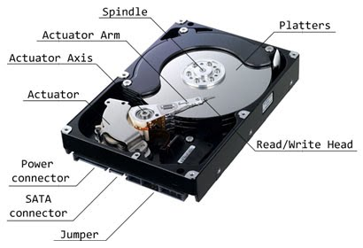

1. *Inspect the item if there is physically damage to the PSU power connector and/or SATA cable.Try difference PSU and/or Sata cable if deemed necessary.*

**Maaring po pakitignan kong meron kayo nakikitang putol o natanggal na parte ng PSU power connector or SATA cable. Palitan ang PSU at Sata cable para makasigurado.**

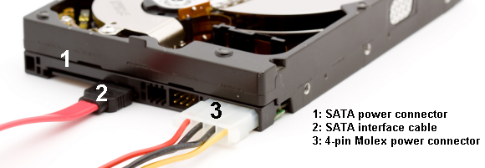

#### *(For pre-owned only) Have you seen the warranty sticker attached to the item? That is our proof that we tested the item first before we ship to you.*

#### Meron po ba kayo nakikitang warranty sticker na nakadikit sa item? Yan ang patunay na tested ang item bago ipadala sa inyo.

1. Check if the HDD is duly readable to the BIOS Setting.

**I check kong ang HDD ay nababasa sa BIOS setting.**

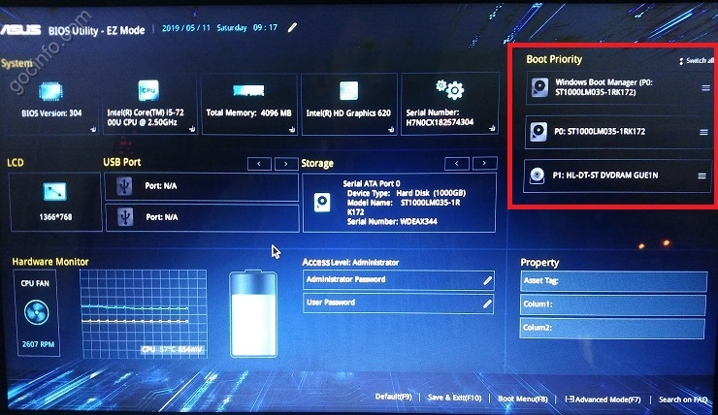

1. *If not readable, unplug the sata cable and plugin to the next sata port of motherboard. Repeat step no. 3.*

**Kapag hindi mabasa, tanggalin ang sata cable at ilipat sa ibang sata port ng motherboard. Ulitin ang step no. 3.**

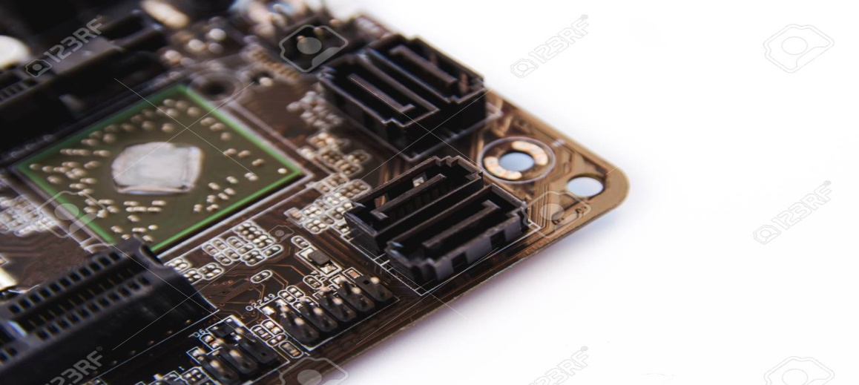

**If still not readable, the HDD is defective. Proceed to final Step**

**Kapag hindi pa rin mabasa, ang HDD ay defective. Magpunta sa huling step.**

1. If HDD is detected in BIOS setting, check the health of HDD Sentinel. Download the application Here!

**Kapag ang HDD ay nabasa sa BIOS setting, check ang Health Sentinel nito. Paki download dito!**

Click me = > <https://www.mediafire.com/file/dnxn066ndsmmpsg/Hard_Disk_Sentinel_Pro_4.71.7_Build_8128_Beta_Multilingual_%252B_Patch_%255BSadeemPC%255D.rar/file?fbclid=IwAR024_r6D5m5RsiEuhOtwCoIqL_7mJ6KG-I6fwkqdAHGiNhEiX_-EdrF5cU>

1. **If the health is lower the 100% healthy, impression is there is bad sector. HDD is defective**

Kapag ang Health ay mas mababa sa 100%, meron bad sector ang HDD. Ito ay defective.

1. *If all above testing failed, request for return and we will promptly accept it.*

**Kong ang lahat ng nasa taas ay nabigo, mag return request lamang po kayo at agad naming etong tatangapin.**

1. **Not covered by Warranty**

If the health is 100%, HDD is perfectly working. The OS Windows is corrupt, that’s why it cannot proceed to installation. Better change the OS bootable device.

**Kapag ang Health ay 100%, ang HDD ay siguradong gumagana. Ang OS Windows ay corrupt, dahilan kaya hindi makatuloy sa installation. Palitan ang OS bootable device.**

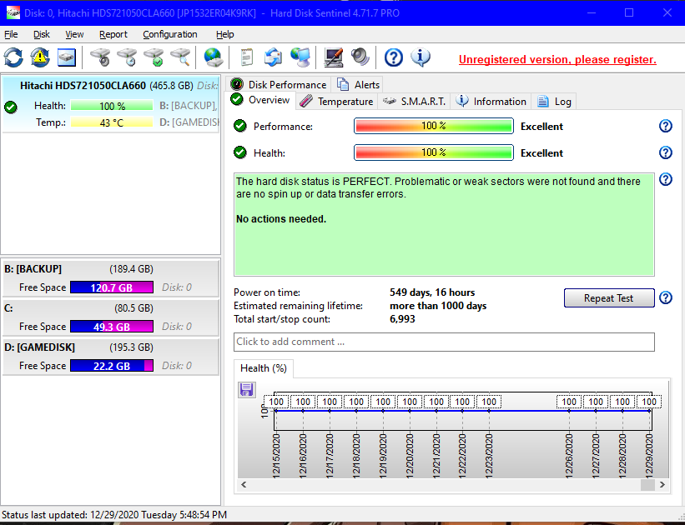

1. **Buyer’s Findings:**
2. **Bestein PC Quality control Final Findings upon receipt of item:**

**BASIC TROUBLESHOOTING**

**KEYBOARD AND MOUSE checklist – must be completely followed**

1. *Inspect the item if there is physically damage such as loosen/ exposed wire, bent or broken parts of to the keyboard/mouse.*

**Maaring po pakitignan kong meron kayo nakikitang putol o natanggal na parte ng keyboard/mouse.**

#### *Check the usb/ps2 port if properly plugin to the working sata port. Restart pc or laptop if necessary.*

#### Mangyari po suriin ang *usb/ps2 port* kong ito’y nakalapat ng mabuti sa gumaganang sata port ng iyong pc or laptop. Restart ang pc o laptop kong kinakailangan.

1. ***(Isolation)*** *Try our keyboard/mouse to another working pc or laptop (not on the first device being used). Please restart after plugin then retest.*

**(Pagbubukod) Subukan itest ang aming keyboard/mouse****sa ibang pc or laptop na gumagana (wag sa unang ginamit na pc or laptop). Paki restart pagkatapus iplugin, then retest po.**

1. *Go to* [*the*](https://online-voice-recorder.com/) *following website link to test the item and show picture of testing result*
2. *Mouse -* [*https://www.onlinemictest.com/mouse-test/*](https://www.onlinemictest.com/mouse-test/)
3. *Keyboard -* [*https://www.keyboardtester.com/*](https://www.keyboardtester.com/)

***Magpunta sa nabangit na website link para ma test ang item at ipakita ang larawan ng resulta ng testing.***

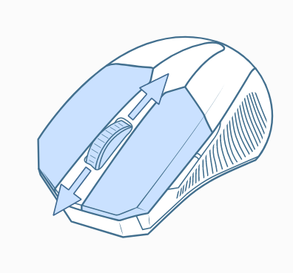

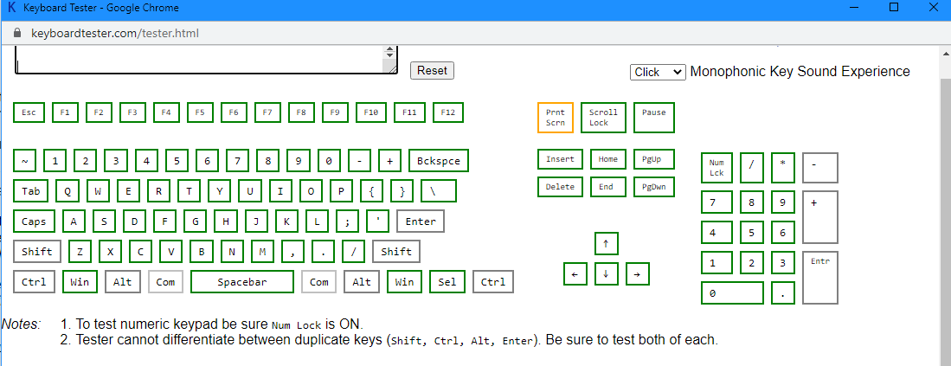

1. *If all above testing failed, request for return and we will promptly accept it.*

**Kong ang lahat ng nasa taas ay nabigo, mag return request lamang po kayo at agad naming etong tatangapin.**

1. **Buyer’s Findings:**
2. **Bestein PC Quality control Final Findings upon receipt of item:**

**BASIC TROUBLESHOOTING**

**RAM checklist – must be completely followed**

1. *Inspect the item if there is physically damage such as bent or broken pin of the RAM .*

**Maaring po pakitignan kong meron kayo nakikitang putol o natanggal na pin ng RAM.**

1. *Check if your motherboard is compatible to your RAM (DDR3-240 pin or DDR4-288 pin supported)*

**Paki check kong ang iyong motherboard ay akma sa nabiling RAM (DDR3-240 pin or DDR4-288 pin supported)**

#### *Check the ram if properly plugin to the working ram slot of the motherboard.You will hear click sound if successfully plugin to the notches.*

#### Mangyari po suriin ang RAM kong ito’y nakalapat ng mabuti sa ram slot na gumagana na motherboard. May maririnig kayong click sound kapag ito’y matagumpay na nakalapat sa notches.

1. ***(Isolation)*** *Try our RAM to another working motherboard (not on the first motherboard being used). Please restart after plugin then retest.*

**(Pagbubukod) Subukan itest ang RAM sa ibang motherboard na gumagana (wag sa unang ginamit na motherboard). Paki restart pagkatapus iplugin, then retest po.**

1. *If all above testing failed, request for return and we will promptly accept it.*

**Kong ang lahat ng nasa taas ay nabigo, mag return request lamang po kayo at agad naming etong tatangapin.**

1. **Buyer’s Findings:**
2. **Bestein PC Quality control Final Findings upon receipt of item:**

**BASIC TROUBLESHOOTING**

**CAMERA checklist – must be completely followed**

1. *Inspect the item if there is physically damage such as loosen/ exposed wire, broken parts inside or outside of the camera.*

**Maaring po pakitignan kong meron kayo nakikitang putol o nabalatan na wire, nabali o may nabasag na parte sa loob o labas ng camera.**

1. *Go to* [*the*](https://online-voice-recorder.com/) *website link to test the item and show picture and video recording result*

**click me =>** [**https://splitcam.com/download**](https://splitcam.com/download)

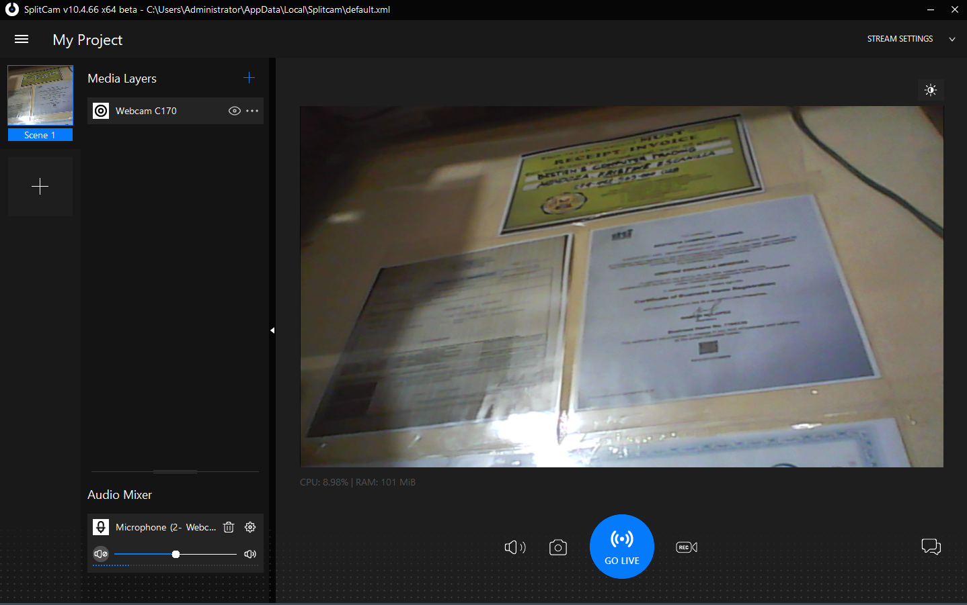

1. *If all above testing failed, request for return and we will promptly accept it.*

**Kong ang lahat ng nasa taas ay nabigo, mag return request lamang po kayo at agad naming etong tatangapin.**

1. **Buyer’s Findings:**
2. **Bestein PC Quality control Final Findings upon receipt of item:**

**BASIC TROUBLESHOOTING**

**CABLE CONNECTOR/ ADAPTER checklist – must be completely followed**

1. *Inspect the item if there is physically damage such as loosen/ exposed wire, broken parts inside or outside of the cable/adapter.*

**Maaring po pakitignan kong meron kayo nakikitang putol o nabalatan na wire, nabali o may nabasag na parte sa loob o labas ng cable/adapter.**

#### *Check the cable pin if properly plugin to the monitor and pc or laptop. Check the left and right screw if tightly screwed.*

#### Mangyari po suriin ang cable pin kong ito’y nakalapat ng mabuti sa monitor at pc o laptop. Suriin mabuti kong ang magkabilang screws ay mahigpit na nakabaon.

1. ***(Isolation)*** *Try our cable connector/ adapter to another working monitor and pc or laptop (not on the first device being used). Please restart after plugin then retest.*

**(Pagbubukod) Subukan itest ang aming cable connector/ adapter sa ibang pc o laptop at monitor na gumagana (wag sa unang ginamit na pc or laptop at monitor). Paki restart pagkatapus iplugin, then retest po.**

1. *If all above testing failed, request for return and we will promptly accept it.*

**Kong ang lahat ng nasa taas ay nabigo, mag return request lamang po kayo at agad naming etong tatangapin.**

1. **Buyer’s Findings:**
2. **Bestein PC Quality control Final Findings upon receipt of item:**

**BASIC TROUBLESHOOTING**

**MONITOR CHECKLIST checklist – must be completely followed**

1. *Inspect the item if there is physically damage such as loosen/ exposed wire, broken parts inside or outside of the monitor.*

**Maari po pakitignan kong meron kayo nakikitang putol o nabalatan na wire, nabali o may nabasag na parte sa loob o labas ng monitor.**

#### *Check the cable pin if properly plugin to the monitor and pc or laptop. Check the left and right screw if properly tightly screwed.*

#### Mangyari po suriin ang cable pin kong ito’y nakalapat ng mabuti sa monitor at pc o laptop. Suriin mabuti kong ang magkabilang screws ay mahigpit na nakabaon.

1. *If you have videocard installed in your pc, please make sure it is 100% with display to your existing monitor before plugin to our monitor.*

**Kung mayroon kang naka-install na video card sa iyong pc, mangyaring tiyaking 100% itong may display sa iyong dating monitor bago subukan ipluin sa aming monitor.**

1. ***(Isolation)*** *Try our monitor to another working pc or laptop (not on the first device being used). Please restart after plugin then retest.*

**(Pagbubukod) Subukan itest ang aming monitor sa ibang pc o laptop at monitor na gumagana (wag sa unang ginamit na pc or laptop). Paki restart pagkatapus iplugin, then retest po.**

1. *If all above testing failed, request for return and we will promptly accept it.*

**Kong ang lahat ng nasa taas ay nabigo, mag return request lamang po kayo at agad naming etong tatangapin.**

1. **Buyer’s Findings:**
2. **Bestein PC Quality control Final Findings upon receipt of item:**

**BASIC TROUBLESHOOTING**

**FAN checklist – must be completely followed**

1. *Inspect the item if there is physically damage such as loosen/ exposed wire, broken parts of the fan.*

**Maari po pakitignan kong meron kayo nakikitang putol o nabalatan na wire, nabali o may nabasag na parte sa fan.**

#### *Check the molex pin and/or SATA if properly plugin to the Power Supply Unit(PSU).*

#### Mangyari po suriin ang *molex pin and/or SATA* pin kong ito’y nakalapat ng mabuti sa monitor at pc o laptop.

1. Check the fan voltage if properly pluggin to PSU or other devices with 12v or 220v. Carefully read the description found in the sticker of the fan. Make sure it is plugin to the right voltage to avoid explosion.

**Suriin ang boltahe ng fan kung nakalapat eto ng mabuti sa PSU o iba pang devices na meron 12v or 220v. Basahin mabuti ang description na matatagpuan sa sticker ng fan. Siguraduhin tama ang boltahe nito para maiwasan ang pagputok nito.**

1. ***(Isolation)*** *Try our fan to another working PSU (not on the first device being used). Please restart after plugin then retest.*

**(Pagbubukod) Subukan itest ang aming fan sa ibang PSU na gumagana (wag sa unang ginamit na pc or laptop). Paki restart pagkatapus iplugin, then retest po.**

1. *If all above testing failed, request for return and we will promptly accept it.*

**Kong ang lahat ng nasa taas ay nabigo, mag return request lamang po kayo at agad naming etong tatangapin.**

1. **Buyer’s Findings:**
2. **Bestein PC Quality control Final Findings upon receipt of item:**